Ben van Berkel
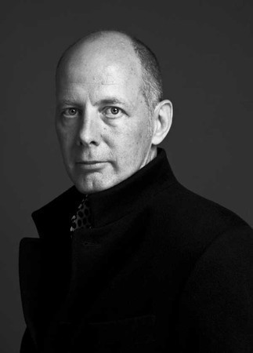
Ben van Berkel (born 1957) is a Dutch architect. He studied architecture at the Rietveld Academy in Amsterdam, and at the Architectural Association in London, receiving the AA Diploma with Honours in 1987.

In 1988 he and Caroline Bos set up an architectural practice in Amsterdam named Van Berkel & Bos Architectuurbureau, which realized, amongst others projects, the Karbouw office building, the Erasmus Bridge in Rotterdam, Museum Het Valkhof in Nijmegen, the Moebius house, and the NMR facilities for the University of Utrecht.

In 1998 van Berkel and Bos relaunched their practice as UNStudio, the UN standing for "United Net". UNStudio presents itself as a network of specialists in architecture, urban development and infrastructure. With UNStudio, van Berkel has built several projects, including the Mercedes-Benz Museum in Stuttgart, a façade and interior renovation for the Galleria Department store in Seoul, Korea, and a private villa in up-state New York. Current projects are the restructuring of the station area of Arnhem, a masterplan for Basauri, Spain, the Dance Palace in Saint Petersburg, Russia and the design and restructuring of the Harbor Ponte Parodi in Genoa. In 2009 New Amsterdam Pavilion in Battery Park in Manhattan was revealed. The pavilion was presented to the city of New York by the Dutch government to celebrate 400 years of relations between New York and the Netherlands.

Ben van Berkel has lectured and taught at many architectural schools around the world. He has led Diploma Units at the Berlage Institute in Rotterdam (1992-1993) and the Architectural Association in London (1999). Before he became Professor Conceptual Design at the Städelschule in Frankfurt in 2001, he was Visiting Professor at Columbia University, Princeton University and Harvard University. In 2011 Ben van Berkel was appointed the Kenzo Tange Chair at the Harvard Graduate School of Design. Central to his teaching is the inclusive approach of architectural works integrating virtual and material organisation and engineering constructions.

8.1 Personal awards and affiliations

Member of advisory board for Gehry Technologies (2011)
RIBA International Fellowship (2009)
Charles Jencks Award (2007)
1822-Kunstpreis 2003 (Mercedes-Benz Museum, Stuttgart) (2003)
Member of Honor of the Bund Deutsche Architekten (1997)
Charlotte Köhler Award (1991)
British Council Fellowship (1986)
Eileen Gray Award (1983)

8.2 Selected projects
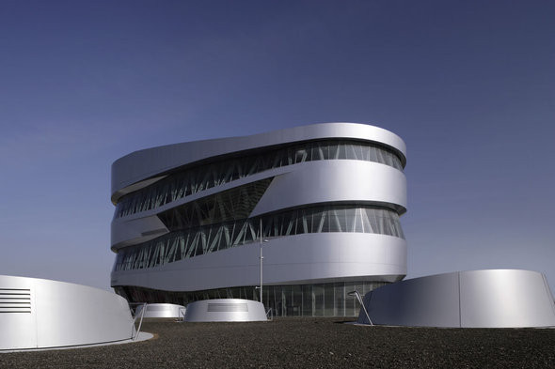  MERSEDES-BENZ MUSEUM | 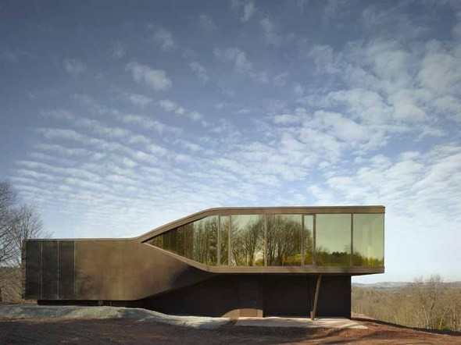  VILA NM
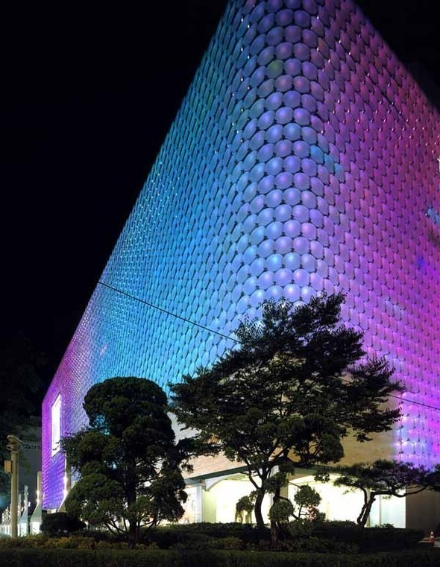  GALLERIA DEPARTMENT STORE | 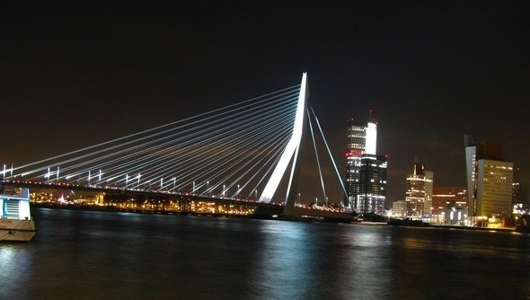  THE ERASMUS BRIDGE
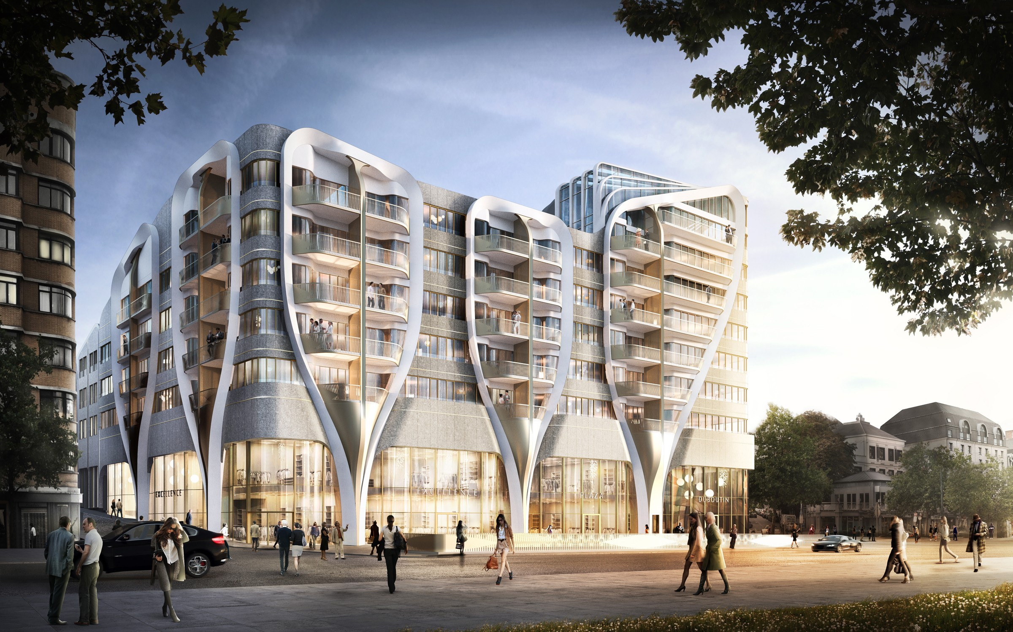

The mixed-use retail and residential complex is located on the Avenue de la Toison d'Or, between the two historical gates, the Porte Louise and the Port de Namur. Essential to the design is the urban context and the connection to the existing buildings. In addition, the programme and the sustainable aspects of the project form decisive elements. The strong verticality of the existing facade rhythm was continued in the design for the Toison d'Or building. The duality of the programme (retail and apartments) is translated into the façade design by means of V-shaped portals which act as a visual link between the two functions. These portals further create diversity and rhythm in the facade, in addition to emphasising the terrace spaces of the upper apartments. Le Toison d'Or contains varied sized apartments, 13,000 m2 of commercial space and 400 parking spaces.
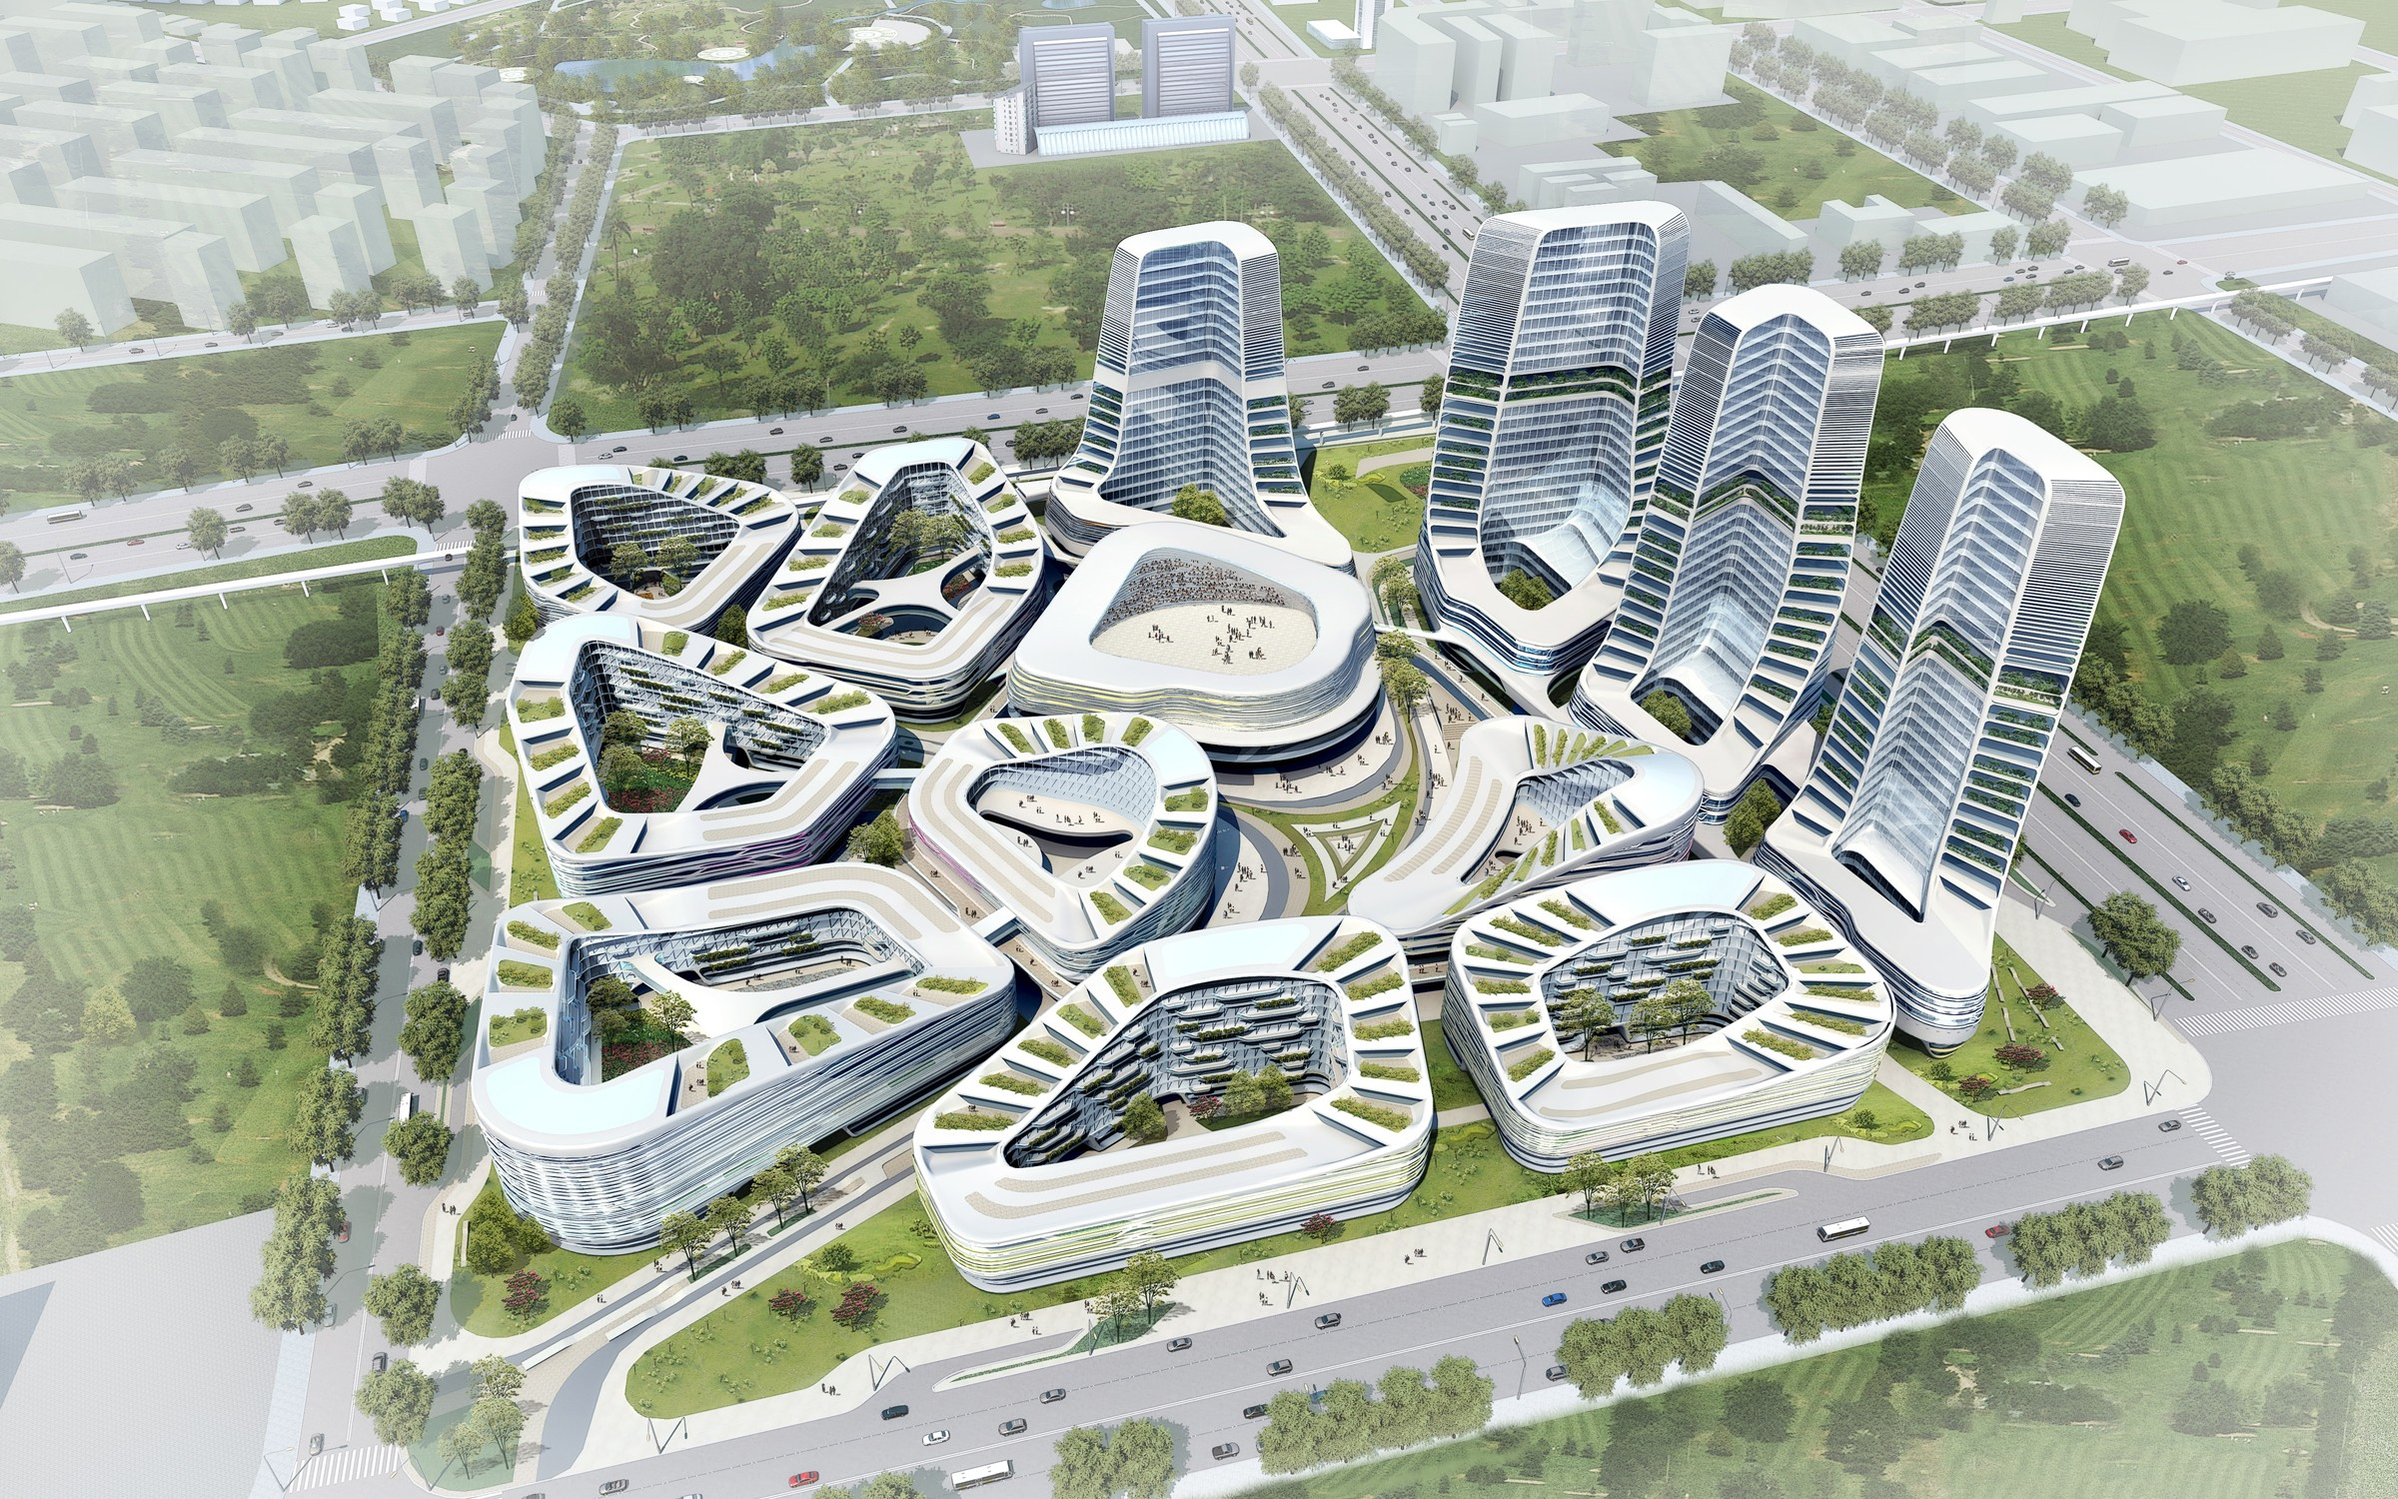
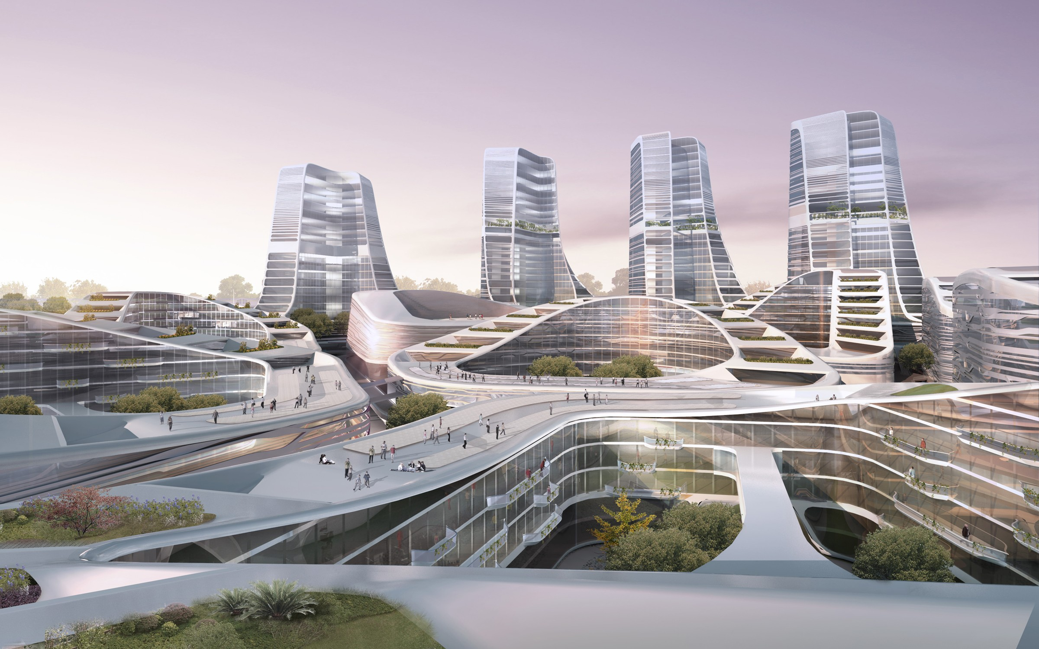

International Investment Square
Beijing, China, 2009

The buildings in the master plan for the International Investement Square in Beijing fall into two distinct categories, low rise buildings and towers. The urban organisation utilizes a consistent distribution of buildings in rings of various shapes and sizes, with each building encircling an internal courtyard. The building programme is distributed over three distinct yet interrelated neighbourhoods. Each of these is subdivided again in order to generate a new level of privacy and individuality. A third level is introduced by the semi-public courtyards at the core of the enclosed building blocks. The shapes of the roofs are articulated so as to achieve a harmonious and coherent master plan, as well as ensuring good sun orientation and excellent views for the apartments.

8.2.1 Current Projects

Beijing New Scitech Reconstruction (2011), Mixed-use, Beijing, China
Shenton Way (2010), Mixed-use, Singapore
Singapore University of Technology and Design (2010), Singapore
Scotts Road (2010), Residential Tower, Singapore
Entre Les Deux Portes (2010), Commercial and Residential Complex, Brussels, Belgium
Twofour54 (2009), Media Campus, Abu Dhabi, United Arab Emirates
Dance Palace (2009), Saint Petersburg, Russia
Raffles City (2008), Mixed-use, Hangzhou, China
Post Rotterdam (2007), Lifestyle Retail Centre and Hotel, Rotterdam, The Netherlands
Arnhem Central Station (1996), Arnhem, The Netherlands
Ponte Parodi (2000), Harbor Redevelopment, Genoa, Italy

8.2.2 Past projects

Exhibition Motion Matters (2011), Harvard University Graduate School of Design, Cambridge, United States of America
New Amsterdam Chair (2011-2011), Wilde + Spieth
Youturn Pavilion (2010), Sao Paulo Art Biennale, Sao Paulo, Brasil
SitTable (2010), PROOFF
Diakonessenhuis Health Care Campus (2009), Utrecht, The Netherlands
Creative Zone Masterplan (2009), Beijing, China
Twofour54 Media Center (2009), Abu Dhabi, United Arab Emirates
Galleria Cheonan Department Store (2008-2010), Cheonan, South-Korea
Lock Island Bridges (2008), Dubai, United Arab Emirates
Mychair (2008), Walter Knoll
New Amsterdam Pavilion (2008 - 2009), New York, United States of America
Education Executive Agency and Tax Offices (2007-2011), Groningen, The Netherlands
Five Franklin Place Residential Tower (2006), New York, United States of America
Holiday Home (2006), Institute for Contemporary Art, Philadelphia, United States of America
Star Place Department Store (2006-2008), Kaohsiung, Taiwan
Research Laboratory (2003-2008), University Groningen, Groningen, The Netherlands
Galleria Department Store (2003-2005), Seoul, South-Korea
UNStudio Office Tower (2003-2010), South- Axis Amsterdam, The Netherlands
Theatre Agora (2002-2007), Lelystad, The Netherlands
Mercedes-Benz Museum (2001-2006), Stuttgart, Germany
VilLA NM (2000-2007), Upstate New York, USA
Music Faculty and Theatre (1998-2009), University Graz, Graz, Austria
Möbius House (1993-1998), Naarden, The Netherlands
Het Valkhof Museum (1995-1998), Nijmegen, The Netherlands
Erasmus Bridge (1991-1996), Rotterdam, The Netherlands

9 Zvi Hecker

Zvi Hecker was born on May 31, 1931 in Krakow, Poland. He grew up in Poland and Samarkand. He began his education in architecture at the Cracow University of Technology. He immigrated to Israel in 1950. There he studied architecture at the Technion - Israel Institute of Technology, graduating in 1955. At the Technion, Eldar Sharon was a classmate, and Alfred Neumann was their professor. Between 1955 and 1957, he studied painting at the Avni Institute of Art and Design, before beginning his career as an architect. Between 1957 and 1959, Hecker served in the Combat Engineering Corps of the Israel Defense Forces.

9.1 Architectural career

After his military service, he founded a firm with Eldar Sharon (until 1964) and Alfred Neumann (until 1966). The physical and economic conditions in Israel at the time, allowed them to complete a fair number of works in a relatively brief period of time, which brought international attention. Their joint works include the Mediterranean Sea Club in Achzib (1960–1961), Dubiner House (1963), the Chaim Laskov Officer Training School (1963–1967) Bahad 1, the main officer training school of the Israel Defense Forces, just later the synagogue (1969–1971) at the same academy, and the Bat Yam city hall (1963–1969). Their designs shared aspects in common with the metabolist movement,[6] borrowing metaphoric shapes from nature for use in planning morphological structures. The modularity of these works, such as the Dubiner House, provided an architectural precedent for the Habitat 67 project by Moshe Safdie.

Hecker resides in Berlin and Tel Aviv. He has been involved in planning projects for the German Jewish community as well as other international projects.

9.2 Projects

The early projects of Zvi Hecker, designed in partnership with Sharon and Neumann, have architectural qualities that were developed later in his career. The officer school (Bahad 1) was built to give a respectable living environment to soldiers in the Negev desert, and special emphasis was given to the large spaces between the structures, in order to form a micro-environment there, separating the people inside from the harsh desert outskirts. Raw concrete was chosen because it did not require constant maintenance and renovation in light of the strong sandy winds. About the school, Hecker said: "The location of the base has a special relevance to the vision of David Ben-Gurion. To build such an important school in a place which isn't the center of the country – in my opinion, that's the positive side of the State of Israel". The academy was supplemented later with a synagogue, whose form was complementary and contrasting. The Oxford Dictionary of Architecture and Landscape Architecture says of the architect's approach to its design, "Eschewing the right angles of international modernism, he turned to crystalline geometry found in nature [...]"
Bat Yam City Hall

Another of the Zvi Hecker's projects in partnership, the Bat Yam City Hall shows the recurrence of geometrical invention that exists throughout his work. One architectural significance of the Bat Yam City Hall- its formal concept, is that it is an inverted pyramid. It is linked to other works of architecture such as Boston City Hall through this form, in addition to their program, similar materials, and time period. The building is patterned on a diagonal grid with concrete, which provides both its structure and aesthetics. The importance of this building was recognized in 1975 with perspective and section illustrations on a postage stamp in the Architecture in Israel series. As of 2003, Bat Yam City Hall was removed of its signature light shafts, rather than having them renovated. This was because of a perceived structural instability due to weathering over time. Of this removal Dr. Ami Ran wrote, "From an architectural standpoint, removing them is equivalent to dousing the Statue of Liberty's torch."

Among several projects for memorials, Zvi Hecker designed the solemn Page Memorial (1996) with Micha Ullmann and Eyal Weizmann. This site-specific memorial commemorates the Jewish community of Kreuzberg, and their Lindenstrasse synagogue which was designed in 1891 by architects Cremer & Wolffenstein. What was once one of the largest religious buildings in Berlin, with a capacity of 1800; was ruined by the Nazis in the 1938 Kristallnacht pogrom. On the original floor plan, the benches of the synagogue were recreated in concrete, and where the bimah stood, trees are now planted. The designers conceived of the benches as sentences on the pages of the Talmud.

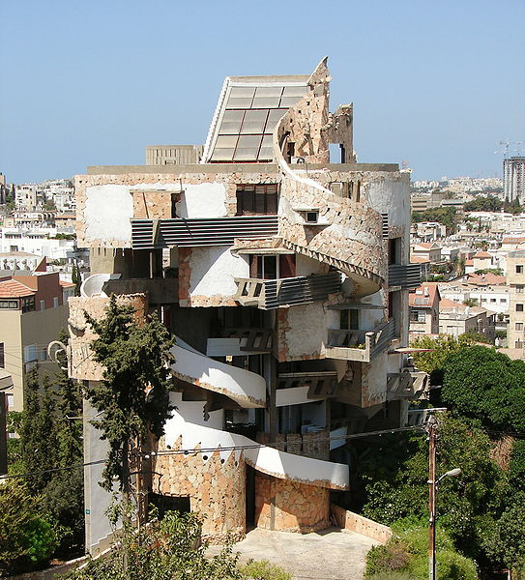  SpiralHouse | 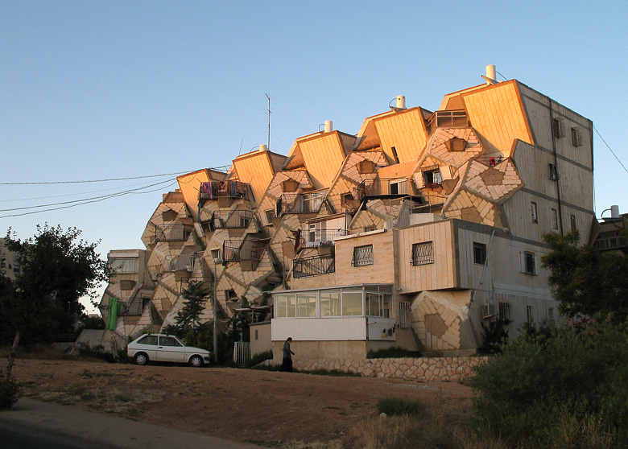  Ramot polin
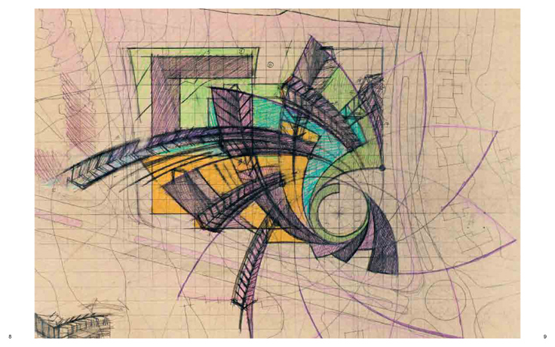 | 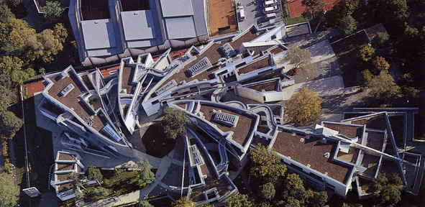
Heinz Galinski School, Berlin, 1995, Zvi Hecker

